WEEK-07-SEARCHING ALGORITHMS-LINEAR AND BINARY

WEEK 07-01-PRACTICE SESSION CODING REG NO : 240901065

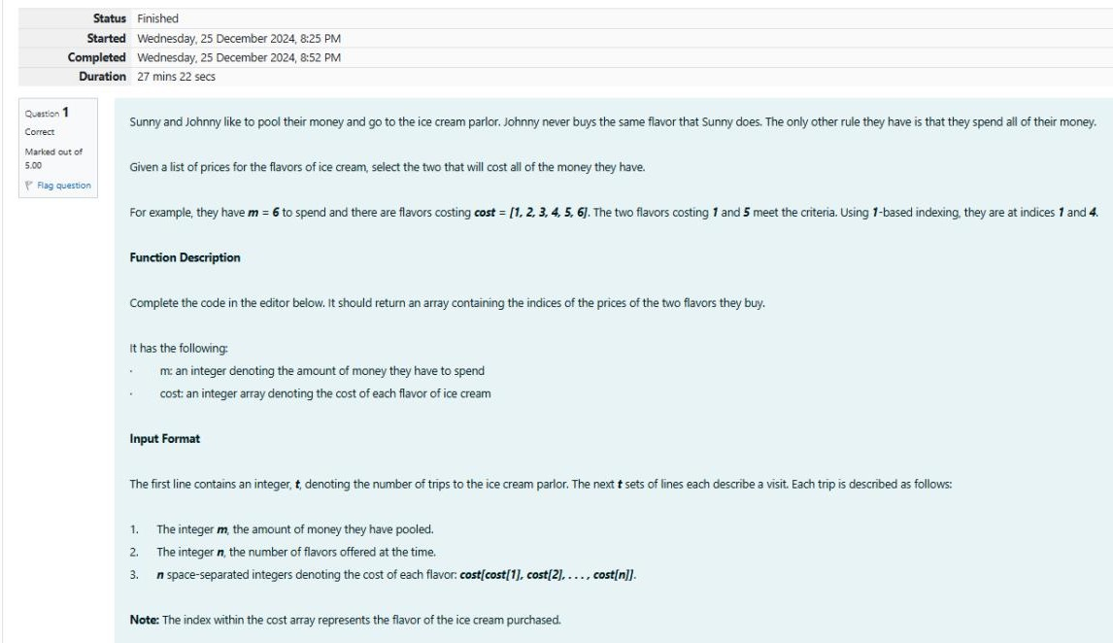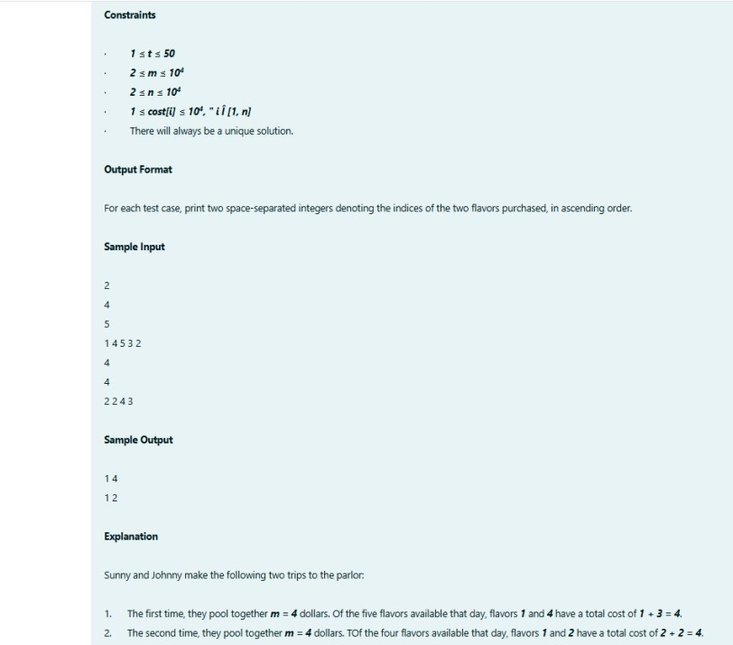NAME : NETHRA P Q1)

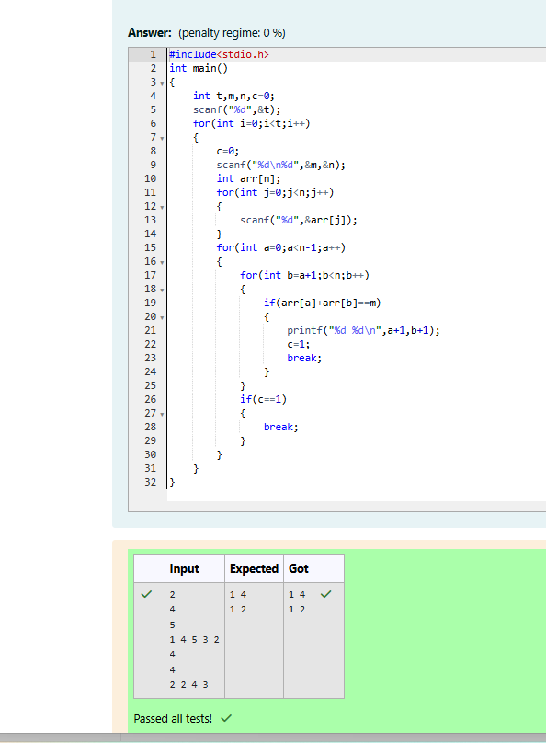

WEEK 07-01-PRACTICE SESSION CODING

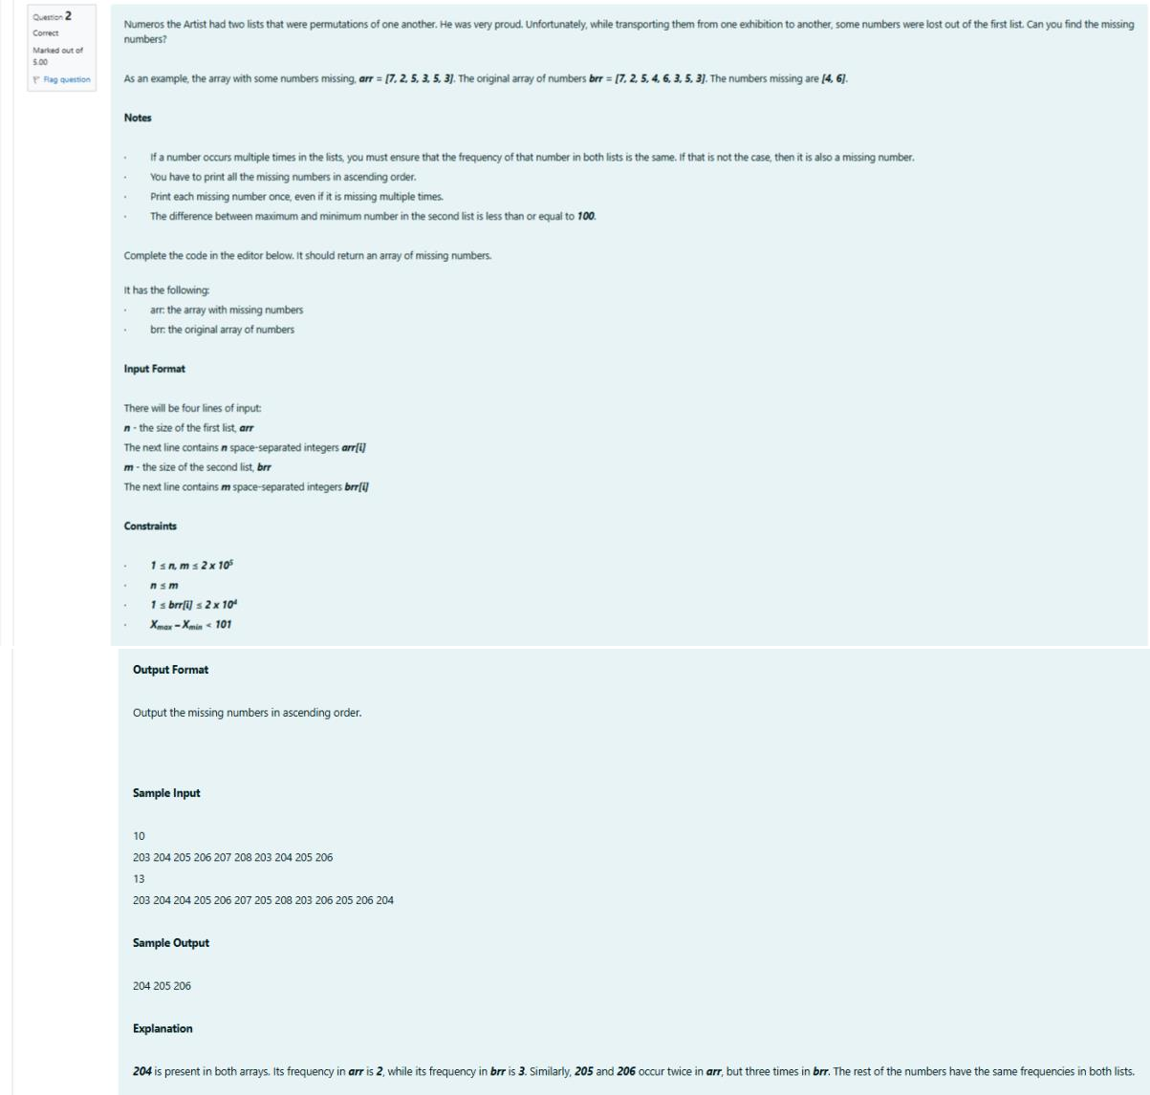REG NO : 240901065 NAME : NETHRA P Q2)

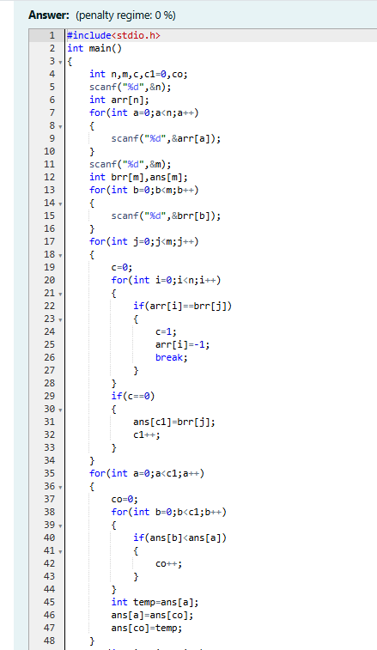

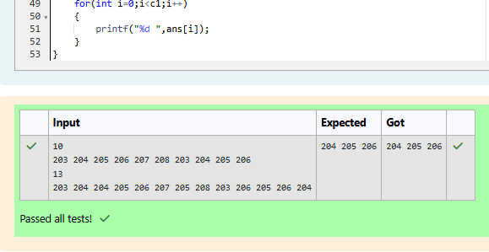

WEEK 07-01-PRACTICE SESSION CODING REG NO : 240901065

NAME : NETHRA P Q3)

